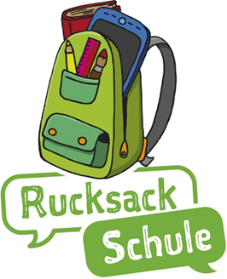
Dear parents,
we are happy to announce the possibility to discover the „Play and Language“ project together with You and Your child in both your mother tongue and German.
In cooperation with the school, the Municipal Integration Centre offers You and Your child a free project „ Rucksack Schule“.
„Rucksack Schule“ aims at developing general linguistic competence and takes up classroom-based topics.
You will meet other parents once a week for 2 hours for a period of 9 months. The group will be supervised by a qualified parents coach. Thereby, you will be able to experience how to encourage and support your child`s general and linguistic development and your native language. You will obtain materials based on lesson content together with ideas and exercises to explore the daily choice of activities with your children. In addition, your child will be given support in German language by educational staff of the school.
With the „Rucksack Schule“ project ,you will be acknowledged not only as an expert of you child`s upbringing but also as a teacher of your mother tongue!
We are looking forward to seeing you!
Should you have any more questions, feel free to contact your school.

